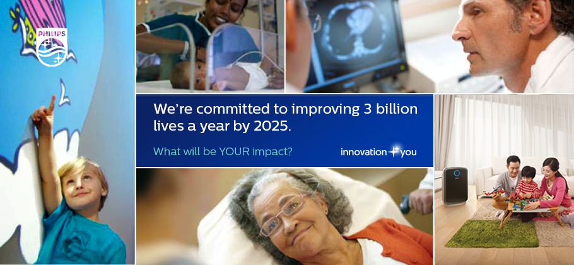

Your Challenge
Philips Healthcare is one of the world’s leading medical device companies. We are continuously improving quality of people’s lives through our innovative developments across the Healthcare Sector.

The Health Systems business is now hiring for Engineering Intern(s) to join their Field Service team in Ho Chi Minh office. The intern(s) will have the opportunity to work with experiencedservice engineersand help support healthcare equipment installation & technical support according to Philips standards and as per committed time frame to our customers in Vietnam.

Your Responsibilities
- Shadow & support Philips Field Service Engineers to perform installation, planned maintenance and corrective action work for Philips Ultrasound and PCMS* modalities
- Help Customer team to translate simple Philips documents from English to Vietnamese
- Help to update service schedules/records and support the preparation of service reports
- Support Philips Call Center on the tools management
*PCMS stands for Patient Care & Monitoring Solutions
To be considered, you should possess the following:
- Currently pursuing a degree with relevant engineering discipline i.e. Biomedical preferred
- Basicknowledge of Electronics, Medical, IT equipment/software
- Possess strong interest in learning
- Ability to read and understand English technical manual (as translation of technical terms is required)
- Ability to work in a team-based environment
- Ability to travel between the sites in South Viet Nam i.e. from Ca Mau to Da Nang

Our Offer
Due to the diversity of this internship, you can be assured that it will be a great learning opportunity. This internship allows you to apply academic theory to actual work place situations which will enable your career making decision post-graduation.

Internship duration: 12 weeks program beginning in January 2017
How to apply:To apply for the role, please submit your application (resumé /CV; cover letter) to jin.lee@philips.com(Mr. Jin Lee) (cc: fbb@hcmus.edu.vn)
Intership Application deadline is November 30, 2016.

