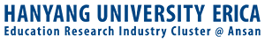
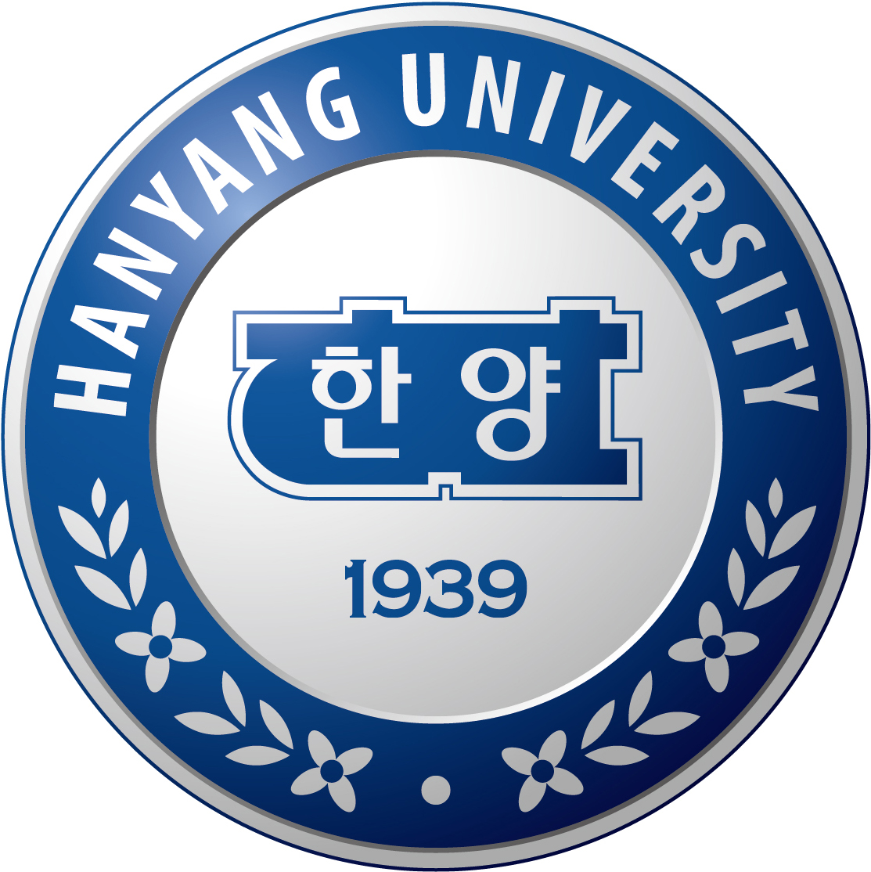

SCHOLARSHIP PROGRAM
HANYANG UNIVERSITY ERICA
APPLICATION GUIDELINE FOR INTERNATIONAL STUDENTS

- Objectives
The Scholarship Program for graduate degrees (Ph.D. or Master & Ph.D. combined) is designed to provide international students with opportunities to study at higher educational institutions in Korea for Doctoral-level degrees, which in turn will contribute to promoting the international exchange in education and to deepening the mutual friendship among countries.
- ELIGIBLE COUNTRIES AND UNIVERSITIES
- MONGOLIA (Mongolian National University, Mongolian University of Science and Technology)
- VIETNAM (Hanoi University of Science and Technology, VNU Hanoi – University of Science, Hanoi Architectural University, Ho Chi Minh City University of Technology, Ho Chi Minh City University of Science – VNU HCM, Ho Chi Minh City University of Technology and Education, Ho Chi Minh City University of International University, Ho Chi Minh City University of the environment and natural resources, University of Architecture Ho Chi Minh City)
- 2018 prospective graduates or students who has finished bachelor or master program within 5 years.
- ACADEMIC PROGRAMS
- Combined Master and Ph.D. Program (Master + Doctoral)
- Doctoral Degree Program (We don’t recruit master only student)
- Field: Engineering, Science (No humanities or social sciences area)
- SCHOLARSHIP BENEFITS
- Tuition fee is covered BY HANYANG ERICA and Advising Professors
- Living Allowance (500,000 ~ 900,000 KRW per month) will be provided by an advising professor every month. (Monthly allowance can vary by each professor)
- Students may pay for 50% of first semester tuition fee which will be reimbursed by professor through monthly allowance.

- QUALIFICATION
Prospective applicants must meet the following condition
- Grades: An applicant must have more than the cumulative grade point average (C.G.P.A.) of 80% (out of 100%)
- Level of Education: An applicant must have graduated or be expected to graduate from (within one year after graduation or graduates with at least two years of experiences in their field of studies, or to be expected to graduate bachelor or master’s degree)
Doctoral Degree Program - Graduates of Master degree diploma holders
Combined Master & Ph.D. Program – Graduates of Bachelor degree diploma holders
- English Language Requirement: IBT TOEFL 70, IELTS 5.5, TOEIC 800, TOEFL ITP 600 and more.
- Korean Language Requirement: TOPIK level 4 and more (Applicants must take Korean Language Course whose TOPIK level is lower than 3)
- REQUIRED DOCUMENTS
- Application form
- Self-Introduction Essay
- Study plan or Research Proposal
- Academic Degree Diploma
- Transcripts
- Recommendation Letter
- Application Fee $150(Unrefundable if student cancel after acceptance)
- APPLICATION (DOCUMENTS SUBMISSION)
- Application submission is available at the international office of the universities where the applicants are belonged to between June 1- July 13, 2018
- SELECTION PROCEDURE
- 1st round selection: Application document screening during July 16-Aug30, 2018
- Appointment of Avising professors
- 2nd round selection: Interview with professors and selection committee
- Announcement of successful applicants

- GENERAL PROCEDURE
DATE | CONTENT
June 1-July 13 | Submission of documents
July 16-Aug30 | Application document Screening
 | Interview
 | Announcement of Successful Students
 | Visa application
 | Visa issuance
 | Prepare to depart
September 10-28 | Hanyang Universiy ERICA Online Application and required documents submission
End of December | Korean Language Preparation Course
 | Tuition Payment (for the first semester, necessary to discuss with each advising professors)
March 1 | Program starts

- KOREAN LANGUAGE CLASS & Korea Settlement Support Program
- Korean class upon arrival in Korea: 7 hours per day and 5 days a week, total of 10 weeks and 350 hours
- Introduction to Korean culture, Guidance to living in Korea, 50 hours of guidance to obtaining visa in Korea
- The reason why this program was added is to help students’ transition to living in Korea more smoothly despite possible language and/or cultural barriers.
- Cost: 2,600,000 KRW
Excludes flight expenses, residence fees, visa application fee
- This Korean settlement support program is held at Hanyang University ERICA
(Korean Language Institution is subject to change and price can vary)
- Information & Materials
  - Hanyang ERICA at a Glance: https://goo.gl/p5MZqi
  - Hanyang ERICA Presentation: https://goo.gl/n7bbGo
  - Admission Guideline: http://www.dic.hanyang.ac.kr/front/admissions/admissions2
  - College of Engineering Science Brochure: https://goo.gl/PeQXcC

