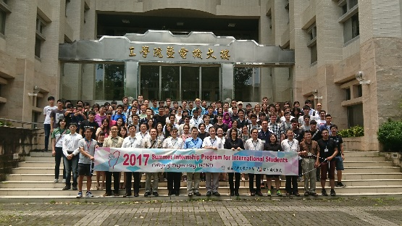
Introduction
This summer internship program is intended for engineering students at the sister institutes of National Chung-Hsing University to delve into the engineering technologies and the cultural beauty of Taiwan.
Geographically located between Japan and Philippines along the west rim of the Pacific Ocean, Taiwan is celebrated for its stunning vibrancy in industrial innovation. It is also one of the leading e-societies in the Asia-Pacific region. These economic achievements have been highly associated with a distinctive culture comprising of a wide array of Chinese and indigenous elements. The technology novelty and the cultural beauty of Taiwan deserve more recognition from the world. To that end, the summer internship program to be held at NCHU offers a series of technical seminars and field trips. We earnestly invite you to join this discovery trip.

About College of Engineering at NCHU
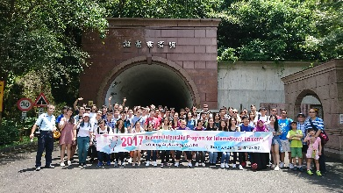
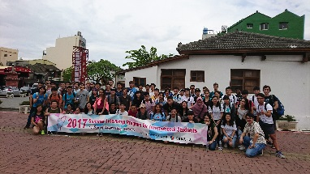
The College of Engineering at NCHU is composed of six departments and four graduate institutes. The six departments are Department of Civil Engineering, Department of Mechanical Engineering, Department of Environmental Engineering, Department of Electrical Engineering, Department of Chemical Engineering, and Department of Materials Engineering. The four graduate institutes include Graduate Institute of Precision Engineering, Graduate Institute of Communication Engineering, Graduate Institute of Optoelectronic Engineering, and Institute of Biomedical Engineering.

Financing and Personnel Support
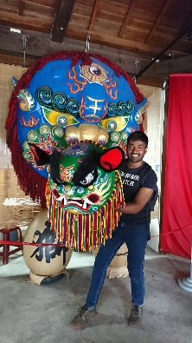
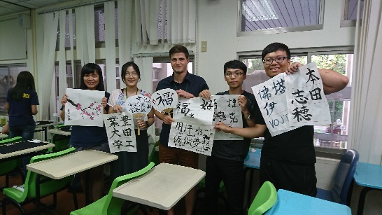
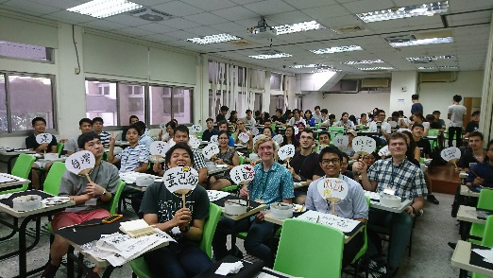
For every student participates the internship program, NCHU will provide accommodations, tuition and food expenses. Information and detailed curriculum of the internship program can be found in the enclosed leaflet. The application form for the internship program is also attached.

July 25– August 8, 2018, Taichung, Taiwan
Days | Date & Day | Morning Activity | Afternoon Activity
Day 0 | 7/25(Wed) | Arrival --Shuttle bus provided from Taiwan Taoyuan International Airport (TPE) to NCHU
Day 1 | 7/26(Thu) | laboratory assignments /Orientation  Opening Ceremony | Culture Courses  Chinese painting calligraphy
Day 2 | 7/27(Fri) | Lab (1) | Lab (2)
Day 3 | 7/28(Sat) | Free time to discover the beauty of Taichung City  Arrange by the laboratory
Day 4 | 7/29(Sun)
Day 5 | 7/30(Mon) | Lab (3) | Lab (4)
Day 6 | 7/31(Tue) | Industry Visit ：  Show Chwan Memorial Hospital | Culture visit ：  Lu Kung Taiwan Historical Town
Day 7 | 8/1(Wed) | Lab (5) | Lab (6)
Day 8 | 8/2(Thu) | Lab (7) | Lab (8)
Day 9 | 8/3(Fri) | Culture visit ：  National Museum of Natural Science
Day 10 | 8/4(Sat) | Free time to discover the beauty of Taichung City  Arrange by the laboratory
Day 11 | 8/5(Sun)
Day 12 | 8/6(Mon) | Lab (9) | Lab (10)
Day 13 | 8/7(Tue) | Presentation preparation Student Presentations and Farewell lunch | Arrange by the laboratory
Day 14 | 8/8(Wed) | Departure Day
*The schedule and activities may be subject to change.
* The schedule is based on Taiwan's local Date/Time (Standard time zone: UTC/GMT +8 hours)
* We offer airport group pickup only on 7/25(6:00-22:00, Taiwan Date/Time) at Taiwan Taoyuan Airport (TPE).
* This program will be conducted mainly in English and Chinese Mandarin. Basic proficiency in English is necessary.
* Contact Information:
TEL+886-4-22840430 ext. 706 Ms. Alice Chen Email：engineer@dragon.nchu.edu.tw

